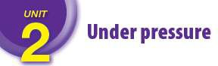
Word | English meaning | Arabic meaning
on the market | available to buy | متاح للشراء
becoming aware of | starting to notice | مدرك / مطلع
exam revision | studying before an exam | مراجعة امتحان
the highest priority | the most important | الأولليةة القصيى
persevere | don’t give up | يثابر
point | purpose | غرض / فائدة
on demand | whenever we want it | عند الحاجة
reward | give sb. something good after work | يكافئ / مكافاة

الدرس الثاني: مفردات الدرس الثاني

Word\ Phrase | English meaning | Arabic meaning
fitting in with peers | being accepted by others in your social group | الانسجام مع الأقران
getting into debt | borrowing money that you have to pay back | الوقوع في الدين
convinced | sure or certain that something is true | مقتنع
nowadays | around the present time | في الوقت الحاضر
fees | money you pay for a service | رسوم
inevitable | impossible to avoid | محتوم/لا مفر منه
personal | connected with yourself | شخصي
disappointed | sad because of an unexpected result | مكتئب/خائب الأمل
impatient | not wanting to wait | قانط/نافذ الصبر
on duty | at work | اثناء الدوام
on order | by request | تحت الطلب
on business | for business purposes | في مهمة عمل
on time | at the appointed time | في الوقت المحدد
on the way | returning | في الطريق الى
on purpose | intentionally | عن قصد
on request | when you ask | بناءً على الطلب

F Choose words from the box and match them with their meanings.

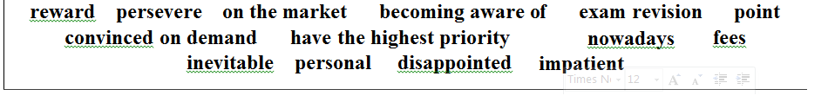

  - available to buy: …………………………
  - starting to notice: …………………………
  - studying before an exam: …………………………
  - are the most important: …………………………
  - don’t give up: …………………………
  - purpose: …………………………
  - whenever they want it: …………………………
  - something good: …………………………
  - sad because of an unexpected result: …………………………
  - not wanting to wait: …………………………
  - money you pay for a service: …………………………
  - connected with yourself: …………………………
  - around the present time: …………………………
  - sure or certain that something is true: …………………………
  - impossible to avoid: …………………………
  - available to buy: …………………………
  - starting to notice: …………………………
  - studying before an exam: …………………………
  - are the most important: …………………………
  - don’t give up: …………………………
  - purpose: …………………………
  - whenever they want it: …………………………
  - something good: …………………………
  - sad because of an unexpected result: …………………………
  - not wanting to wait: …………………………
  - money you pay for a service: …………………………
  - connected with yourself: …………………………
  - around the present time: …………………………
  - sure or certain that something is true: …………………………
  - impossible to avoid: …………………………
Complete the sentences with words from the box.
Complete the sentences with words from the box.

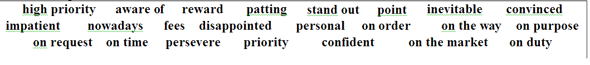

- They stepped on my foot ……………..
- Your car is………… It will be here in a few weeks.
- I can't help you now, but I'll be in about an hour.
- We're late and the train is exactly ……………..
- With all the new products nowadays , it's hard to decide what to buy.
- All people believe that death is ……………..
- I am………. what is going on around me.
- Her parents were because her average in the exams was not high enough.
- Unless you pay the , you won’t enroll at the university.
- Studying for tomorrow’s exam should take over emailing friends.
- The head teacher is going to the students who get the highest marks.
- You may face difficulties at first, but if you , you’ll find it interesting.
- The door is locked. There is no in trying to open it.
- I did well in the interview and I am I’ll be selected for the job.
- A lot of students are not the new system of Tawjihi.
- One of my relatives offered to pay my university ……………..
- We need to be , survive, rise up stronger than before.
- To motivate their sons, parents should them when they do well.
- Please, remind me to buy some sugar home.
- I am afraid the manager is away to Cairo.
- Our teacher is so punctual. He always arrives to his class ……………..
- Students are for the summer holidays to come
- He was because things didn't turn out as he'd hoped
- There are no for children under five.
- Those who through trials will succeed
- I am not of her ability to carry out the task in time .
- You are not the difficulties you will face.
- I'll to become a champion at any sport.
- What's the of telephoning her again?
- He is of his ability to win.
- Police are offering for information leading to a conviction.
- There's nothing we can do to stop it happening; it's ……………..
- I don't go to London much , but I did in the past.
- We can't afford private school ……………..
- With more cars on the road, traffic jams are ……………..
- The car is for your use only.
- We were with our accommodation- we were expecting a luxury apartment.
- Don't be so it's your turn next.
- There's no buying a new phone if the old one still works.
- His parents gave him some money as a for passing his exams .
- While she was her friend's dog, it bit her.
- Making lots of money isn’t a very for him.
- The black cards really on that orange background.
- The most frequent flights were taken by those who were most……………... environmental issues

Choose the correct answers.

- Making lots of money is not a very high (priority / minded) for him.
- She's got a few (personal / error) problems at present.
- You can't always make your brain work on (demand / the way).
- He's away all next week (in / on) business.
- The doctor is (in / on) duty from 9 to 4pm.
- We will be pleased to send you more information (in / on) request.
- That was no accident. I’m sure he did it (in / on) purpose.
- More details will be sent (on request / on demand)
- Please remind me to buy some sugar (on the way / on duty) home
- Ali has travelled to China for two weeks (on business / in business)
- We are late and the train always arrives (on time / in time)
- Soldiers are not allowed to leave their places while they are ( on the way / on duty )
- I don't believe it was an accident. He made it (on duty / on purpose)
- You can’t always make your brain work on (demand / the way)

- Complete the sentences with the verbs in the box. الصندوق من بأفعال الجمل أكمل
يتخلى عن
give up
يتجنب
avoid
يرغب
feel like
يعترض
mind
يواصل
keep
ينهي
finish
1 I didn’t ………cooking anything, so I went out to a café. مقهى الى خرجت لذا ,شيء أي بطبخ أرغب لا
- The important thing is that you should never ………trying. المحاولة عن تتخلى ألا يجب شيء أهم

- I don’t ……… playing computer games, but it isn’t my favourite way of passing the time.
أنا لا أعترض على لعب ألعاب الحاسوب, لكنها ليس طريقتي المفضلة في تمضية الوقت
- The cat crossed the road suddenly and the driver couldn’t ……… hitting it.
قطعت القطة الطريق فجأة ولم يستطع السائق تجنب ضربها
- I’ll call you back as soon as I ……… writing this report.
- He doesn’t like it when people ……… interrupting him.

- I’ll call you back as soon as I ……… writing this report.
He doesn’t like it when people ……… interrupting him

Gerund and infinitive to

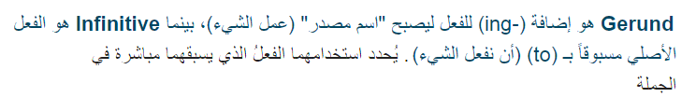

.1قائمة الافعال التي يتبعها صيغة ing))
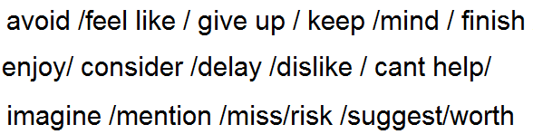
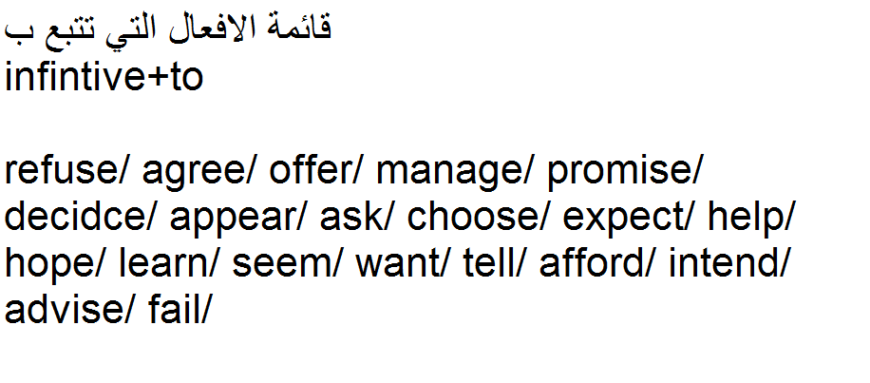
.2
عند النفي نستخدم هذه الصيغة
Not to+ infinitive
مثال:
I ask him not to do this again

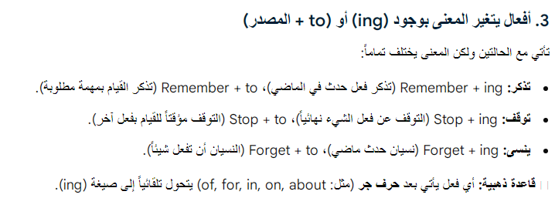
امثلة:
Inf+to
1-please, remember to take your bag before going to school.
تذكر شيئ لم تفعله بعد ويجب عليك القيام بفعله.
V+ing
- The first time I remember hearing my mom sining.
تذكر شيء في الماضي فعلته وانتهى وخطر على بالك الان.
Stop: inf+to
on my way home, I stopped to buy bread.

I saw my teacher and stopped to say hello.

توقف مؤقت/ توقف ليفعل شيء

Stop:verb+ing

You should never stop trying.
You had better stop smoking
I stopped eating fried chicken.

افعال تتبع ب
Inf+to او ing form دون تغيير المعنى

(hate-love+like+prefer) I like swimming

Would hate –would love- would prefer –would like

I would like to eat at home.
I would prefer to drink a cup of tea.
I would hate to see snakes.

هناك افعال مع (حروف جر) تتبع دائما ب gerund
Insist on/ accuse of/ apologize for/ believe in/ blame for/ complain about/ concentrate on/ congratulate on/ depend on/ dream about-of/ get used to/ look forward to /prevent from/ rely on/ succeed in/ specialize in/ stop from/ talk about-of/ think about- of / warn against/ worry about

امثلة:
I apologize for being late.
She insist on learning English.
I am thinking about buying a new house.
He stop from smoking at home.
They complain about going to the party early.
My teacher specialize in teaching English.

ملاحظة : stop يتبعها ing
اذا كان بالجملة شيء سلبي او صعب مثل ( noise/ difficult/ hard/ smoking/ hungry/ talking/ silly

امثلة: stop talking in the class.
Stop smoking, it is so dangerous.
Stop making so much noise into the kitchen.
ملاحظة: remember+to+inf+verb+ (must, should, could, please, did)
امثلة:
Did you remember to bring the book?
Could you remember to close the door?
Please, remember to buy bread.
You should remember to ask the teacher about the exam.
You must remember go to the doctor.

ملاحظة: اذا كان المفعول به ضمير مثل(me/ him/her/them/you/us فان الضمير يتبعه to infinitive

امثلة: The teacher asked us to make revision before the exam.

My father told me to visit my aunt.

The doctors said that chicken make us to get fat.

A Complete the sentences with infinitive form or -ing form of the verb(gerund) in brackets:

- The mechanic managed the machine after hard efforts. (repair)
- People used fire by rubbing two sticks together. (make)
- I decide… for the competition. (not participate)
- Do you feel like ……………….. (go) to a film or would you like (stay) at home?
- I like… (listen) to folk music.
- I'd hate… (be) beside volcano when it started.
- They promised….. ready by 9:00, but I'm not sure they will be. (be)
- She's hoping her study by July 2007. (finish)
- I tried him to agree with your proposal. (persuade)
- We'd better… work early. (starting)
- I know the keys are here, I………..… them down somewhere.( remember, put)
- We were tired , so we…………… lunch.( stop , have)
- We were lost, so we stopped ………………the way . (ask)
- Experts advise us …….this habit. (break)
- I will call you back as soon as I finish…………… this report. (write)
- Not many students enjoy……… for exam. (revise)
- Thank you for agreeing me with this work. (help)
- I enjoy ……………..TV, but tonight I’d like something different. (watch / do)
- They wouldn’t stop……….., but they promised more quietly. (talk / speak)
- ‘Did you remember…………… the birds?’ (feed)
‘Yes, I remember….. them before I left. (feed)

‘My sister refused …….what our father suggested. (do)
- She promised …….(phone ) us as soon as she arrived.
- For some reason he doesn’t seem……… (understand )what you’re saying.
- I’d like some new shoes if I could afford it.(buy)
- He should stop sweet things before meals(eat)
- Some of us fail our time effectively.(manage)
- They told us not too long.(spend)
- She won’t like it if you refuse what she asked.(do)
- I don’t mind………… computer games, but it isn’t my favorite way of passing the time.(play)
- He was getting tired, so he stopped (work)
- Remember regularly and healthily.(eat)
- I remember stressed when I was doing school exams.(feel)
- I quite like …………. the piano for fun, but I hate ……….. for long time. (play practise)

- You should stop like a child. (behave)
- Do you still remember……… the old museum? (visit)
- They don't have much money. They can't afford……. out for a walk. (go)

B Find one mistake in each sentence and correct it.
- If you give me your car I promise driving carefully. ………………..
- I don't mind to stay with children when my mother is away. ………………..
- I remember to eat in this restaurant when I was young. ………………..
- After long discussion , he agreed letting me join the school party. ………………..
- My grandfather stopped to drive when he was 70 years old. ………………..
- You shouldn't give up to try if you want to succeed. ………………..
- Who objects to have a rest for 15 minutes? …………….…
- Bill used to being fit. Now he is in a terrible condition. .……………..
- I must remember thanking Hassan next time I see him. …………………
- Teachers advise us studying hard. ………………….
- I am sure they will decide attending the final meeting. ………………..
- Can you help me doing my homework. …………………
- You cannot stop me to do what I want. ………………….
- I am thinking of buy a new house. ……………….

Choose the correct form.

  - He prefers (to watch watching) TV.
  - Do you feel like (going to go) for a swim?
  - He's thinking of (emigrate emigrating).
  - We had a lot of difficulty in (find finding) the house.
  - I am looking forward to ( see seeing) you.
  - I used (to get to getting) up early.
  - Try to avoid (to travel travelling) in the rush hour.
  - She suggested (to wait waiting) till dawn.
  - It's no point (to look looking) through the keyhole.
  - It is no good (to tell telling) him to work hard
  - It's no use (to cry crying) over spilt milk
  - Would you mind (to close – closing) the door?
  - The children enjoyed (to spend – spending) the holiday in the countryside.
  - He told a really funny joke. We couldn't stop (to laugh - laughing).
  - Did you remember (to give - giving) him any message?
  - Please stop (to talk - talking), I'm trying to finish a letter.
  - Do you remember (to play - playing) computer games together when we were kids?
  - I can remember (being - to be) very proud and happy when I graduated.
  - When you come to school today, remember (to bring - bringing) my book.
  - Students put their pens down and stopped (to write - writing)
  - Please remember (to post – posting) the letter?
  - I'm going to stop (to buy – buying) a few things on my way home.
  - My father stopped (to buy - buying) things which we really don't need.
  - He promised not (to repeat / repeating) his mistake.
  - I’d love (to come / coming) with you to the concert, but I’m really busy.
  - I feel like (to have / having) some coffee.
  - I really enjoyed (to see / seeing) all my old friends again.
  - Would you mind (to close / closing) the door?
  - Rami suggested (to see / seeing) a movie after work.
  - She refused (to speak / speaking) to me after our fight.
  - How did you manage (to get / getting) tickets for that concern?
  - It seems difficult (to know / knowing) everything about the topic.
  - I always remember (to set setting) the alarming o’clock before I go to bed.
  - My parents never stop (to give / giving) me instructions about my study.
  - I always remember (to meet / meeting) her for the first time.
  - If you come to the university , remember (to bring / bringing) along my book.
  - We stopped (to have / having) a rest because we were really sleepy.
  - In the end, I remembered (to bring / bringing) your book! Here it is.
  - You should stop (to eat / eating) so much food. You are getting fat.
  - Did you remember (to unplug/ unplugging) the iron before we left the house?
  - Some of us fail (to manage/managing) our time effectively.
  - Experts advise us (to break/breaking) this habit.
  - They told us not (to spend /spending) too long.
  - I’d like (buying / to buy) some new shoes if I could afford it.
  - They stopped suddenly (to take / taking) photos for the tower as it looks very beautiful.
  - I enjoyed (to meet/meeting) you. I hope (to see / seeing) you again.
  - Remember (to park / parking) your car outside the gate. It's not allowed here.
  - I hate (to see / seeing) people in pain.
  - When you see Kareem, remember (to give / giving) him my regards, won't you?
  - Although there was little chance of rain, he insisted on (to take / taking) his umbrella.
  - In her way home, she always stops (buying /to buy) some bread.
  - They'd love (visiting /to visit) the zoo together.
  - I must remember (thanking - to thank) Hassan next time I see him.
  - He promised (to let / letting) me have the report by next week.
  - He seems (to know / knowing) me, but I don’t remember (to meet / meeting) him before.
  - Where would you like me (to put / putting) these books?
  - Children want to know everything: they never stop (to ask / asking) questions.
  - If he’s busy, I don’t mind (to wait / waiting).
  - We hope he will stop (to ask / asking) such silly questions .
  - She decided (to sell / selling) her new car.
  - I’d like to buy / buying some new shoes.
  - The customer insisted on (to speak / speaking) to the manager.
  - They told us (not to spend / not spending) too long on one task.
  - Young people hate (to get up / getting up) early.
  - She always keeps (to interrupt / interrupting ) me.
  - My father likes (watching / to watch) wrestling on TV.
  - Did you remember ( calling / to call) Nadia today?
  - I still remember ( visiting / to visit ) the pyramids years ago.
  - Would you like me ( repeating / to repeat ) the answer again?
  - He stopped (to have / having ) a break.
  - I stopped (buying / to buy ) some bread on my way home.
  - Our neighbors apologized for (making – to make) such noise.
  - We have stopped(to take – taking) plastic bags. We take our own bags with us when we go shopping.
  - We (got used to – used to) living in an area where everyone knows everyone else's business.
  - I am used (to get to getting) up early.
  - You should remember (to send sending) an email to let them know about the changes.
  - Muneer was doing his homework, and then he stopped (to watch watching) the football match on TV.
  - He remembered (to be being) naughty when he was young.

سؤال مهم على كلمات الوحدة التي تأتي مع حرف الجر((on

تحت الطلب
on order
في الطريق الى
on the way
عمداً
on purpose
في مهمة/عمل
on business
بناءً على الطلب
on request
عند الوصول
on arrival
اثناء الدوام
on duty
في الوقت المحدد
on time

- On at the hotel, please go to the reception desk.

عند الوصول الى الفندق, رجاءً اذهب الى مكتب الاستقبال

- Police officers only have to wear uniforms when they’re on ………….
يجب على ضباط الشرطة أن يلبسوا لباس موحد فقط عندما يكونوا في الخدمة(اثناء الدوام)
- The book you need is on………….. and will probably be here next week.
الكتاب الذي تحتاجه تحت الطلب ومن المحتمل ان يكون هنا الاسبوع القادم

4.This isn’t a holiday. We’re here on …………
5.He hates people being late, so make sure you’re on ………
6.He stopped to buy a newspaper on the home.
7.I don’t believe it was an accident. I think he did it on عمدا عملها انه أعتقد .حادثة كانت أنها أصدق لا

8. we will be pleased to send you more details on……………………….

هذه ليست عطلة. نحن هنا في مهمة عمل
هو يكره تأخر الناس, لذا تأكد أن تكون في الوقت المحدد
لقد توقف لشراء جريدة في طريقه الى البيت

