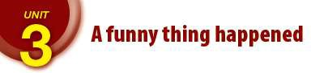
Word | English meaning | Arabic meaning
bald | without hair | اصلع
catch up | meet | يلتقي ب
coincidence | strange\ unexpected event | مصادفة
colleague | someone you study\work with | زميل
come across | find by chance | يجد بالصدفة
error | mistake | خطأ
unintended | saying what is not meant | غير مقصود
keep in touch | stay in contact | يبقى على اتصال
knowledge | things you know | معرفة
mention | say something | يذكر
misunderstanding | getting the wrong idea | سوء فهم
pat | hit gently | يربت/يضرب بلطف
put up | let someone stay at\live in a place | يستضيف
reluctant | not willing | معارض/غير موافق
run into | meet by chance | يقابل بالصدفة
straight | immediately | فورا
the latter | the last one | الأخير
stranger | someone you don't know | غريب
turn out | discover | تحول الي /تبين ان

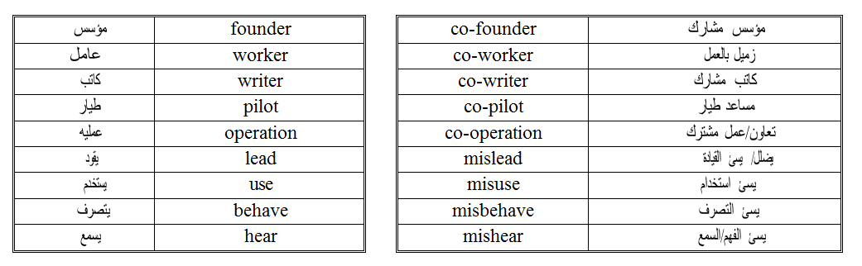
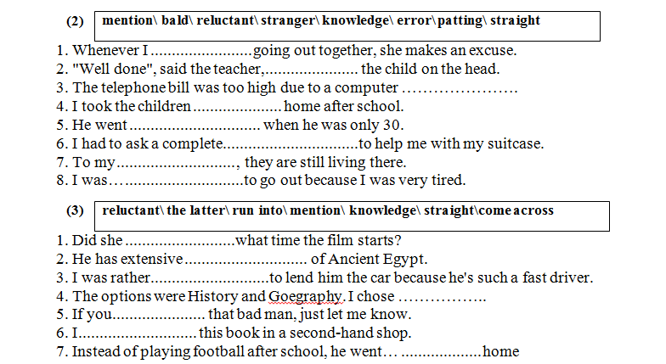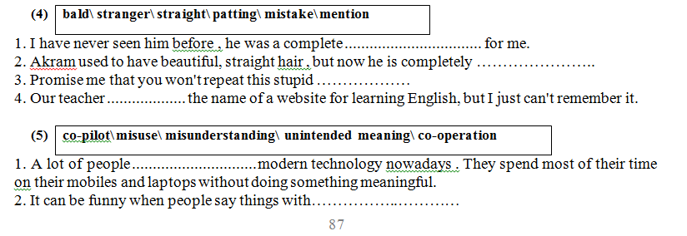
- happens when people just get the wrong idea
- often gets better results than everyone working on his own .
- He flew the plane away, without a ………………………
- I think there’s been a I never ordered these chairs.
- He his position to obtain money dishonestly.

(6)
misbehave\ misleading\ coincidences\ co-operation
- The teacher decided to punish the students who in class.
- Life is full of strange ……………………… . For example , you may go to another country and run into a person you know from home .
- The title of the book is The content is completely different.
- The clubs work in close with the Football Association.
(7)
reluctant\ catch up with\ mention\ latter\ come across
- Don’t forget to my name when you talk to him .
- We our neighbours lost bag, we didn’t expect that at all.
- I a lot of old friends at the party.
- I'm to spend all that money on such a small project.
(8)
error\ put up\ reluctant\ unintended\ straight
- I was to go out because I was very tired.
- That accident was caused by a human ………….
- We at a small hotel for the night after a long travel.
Note: Put up at = يمكث put someone up in = يستضيف

(9)
with\ in\ into
- I was surprised when I ran ………an old friend of mine yesterday.
- While he was away we kept touch by email.
- I caught up a lot of old friends at the party.

(10)
turn out catch up keep in touch run into put up come across
- It was good to with some old friends at the party.
- I didn’t expect to like it but it to be very enjoyable.
- While I was in Jordan I someone I was at school with.
- There’s no need to book a hotel . We can ………… you …….
- Sadly, I didn’t with my closest friends at the party.
- Let's go to a café. I need to with you all.
- After all that media attention, the whole event to be false.
- I was surprised when I an old friend of mine yesterday.
- We ………… our relatives up in our house when they came to visit Palestine.
- I didn’t intend to buy a shirt but I this really nice one in the market.
- I was surprised to Noha when I was in the park.
- While he was away we by email.
- My sister was walking very fast, I couldn't with her.
- When you visit our country, please tell me, I am ready to …… you in my apartment.
- He is cunning. He can black into white, so don’t trust him.
- While I was tidying up my room yesterday, I an old photo of me as a baby.
- I didn't recognize her at first , but it that we were together at the same school
- He was just visiting for a few days, so I him …… in my apartment.
- I am busy now, but we will later for sure
- I have to leave now, but I will do my best to with you as soon as possible.
- When he is far away in another country, he usually with his family by email.

Circle the correct answer.
- If you (mis / co) behave in the class, you'll certainly be punished.
- (Mis / Co) operation usually leads to success.
- We believe her comments were meant to (co / mis) lead us.
- He couldn't fly the plane without a (co-pilot / co-writer).
- I'm sure I didn't say that! You must have (misused / misheard) me.

Complete the sentences using the words in the box with either co- or mis- as prefixes.
worker use behave operation pilot lead heard writer
- Fortunately, there was enough oxygen for the pilot and to make a safe landing.
- The succeeded in landing the plane safely.
- Information in adverts is usually true, but it can people and give them the wrong idea.
- The children sometimes their toys and ends up losing them.
- There's very little between the two neighboring countries.
- Students always get in trouble when they at school.

الزمن السادس: الماضي المستمر
Past continuous

الزمن الماضي المستمر (Past Continuous Tense) هو أحد أهم الأزمنة في اللغة الإنجليزية. نستخدمه للتعبير عن حدث كان مستمراً في وقت معين في الماضي قبل أن ينتهي، أو قبل أن يقطعه حدث آخر.
لنبسط الأمر معاً ونغوص في تفاصيله بطريقة واضحة ومباشرة.

1. صياغة الزمن (Form)
تعتمد الصياغة بشكل أساسي على الفاعل لتحديد الفعل المساعد المناسب (was أو were)، متبوعاً بالفعل مضافاً إليه ing.

أ. حالة الإثبات (Affirmative)
Subject + was/were + Verb(ing)
- was تأتي مع ضمائر المفرد: I, He, She, It (أو أي اسم مفرد).
- were تأتي مع ضمائر الجمع: They, We, You (أو أي اسم جمع).
أمثلة:
- I was watching a movie yesterday evening. (كنتُ أشاهد فيلماً مساء أمس).
- They were playing football at 5 PM. (كانوا يلعبون كرة القدم في الساعة الخامسة).

ب. حالة النفي (Negative)
للنفي، نقوم ببساطة بإضافة أداة النفي not بعد الفعل المساعد:
Subject + was/were + not + Verb(ing)
- was not تختصر إلى wasn't
- were not تختصر إلى weren't
أمثلة:
- She wasn't sleeping when you called. (لم تكن نائمة عندما اتصلت).
- We weren't studying math at that time. (لم نكن ندرس الرياضيات في ذلك الوقت).

ج. حالة السؤال (Question)
إذا أردت تكوين سؤال (نعم/لا)، ضع الفعل المساعد في البداية:
Was/Were + Subject + Verb(ing)?
- Was he cooking dinner? (هل كان يطبخ العشاء؟)
- Were you listening to me? (هل كنت تستمع إلي؟)

متى نستخدم الماضي المستمر؟ (الاستخدامات بالتفصيل
لا تقتصر المسألة على معرفة الصيغة، بل الأهم هو معرفة متى يستدعي الموقف استخدام هذا الزمن:

1. حدث مستمر قطعه حدث آخر قصير
هنا نربط بين زمنين: الماضي المستمر (للحدث الطويل المستمر) والماضي البسيط (للحدث القصير المفاجئ الذي قطع الأول).
- مثال: I was taking a shower when the phone rang. (كنت أستحم [حدث مستمر طويل] عندما رنّ الهاتف [حدث قاطع قصير]).

2. حدثان مستمران في نفس الوقت في الماضي (توازي)
عندما يحدث أمران طويلان بالتزامن دون أن يقطع أحدهما الآخر.
- مثال: While my mother was cooking, my father was reading a book. (بينما كانت أمي تطبخ، كان أبي يقرأ كتاباً).

3. تحديد وقت دقيق في الماضي
عندما لا تكتفي بذكر "أمس" فقط، بل تحدد ساعة معينة كان الحدث مستمراً فيها.
- مثال: Yesterday at 9 PM, we were watching the match. (أمس في التاسعة مساءً، كنا نشاهد المباراة).

3. الكلمات الدالة والروابط (Key Words)
هناك كلمات بمجرد رؤيتها في الجملة، يمكنك تمييز أنك بحاجة للماضي المستمر:
الكلمة | المعنى | طريقة الاستخدام
While | بينما | يأتي بعدها دائماً ماضي مستمر.
As | بينما / كـ | تعمل تماماً مثل While ويتبعها ماضي مستمر.
When | عندما | يتبعها عادةً ماضي بسيط، والجملة الأخرى تكون ماضي مستمر.
All day yesterday | طوال يوم أمس | تدل على استمرارية الحدث لفترة ممتدة في الماضي.
At [specific time] yesterday | في [ساعة محددة] أمس | لتحديد وقت الاستمرار بدقة.
⚠️ تنبيه هام جداً (أفعال الحالة - Stative Verbs):
هناك أفعال في اللغة الإنجليزية لا تقبل الإضافة المستمرة (ing) لأنها تعبر عن حالة ذهنية أو شعورية وليس حركة (مثل: love, hate, know, believe, understand, want).
- خطأ: I was knowing the answer.
- صحيح: I knew the answer. (نستخدم الماضي البسيط بدلاً من المستمر هنا).

Circle the correct answer.
1-If you (mis / co) behave in the class, you'll certainly be punished.
2-(Mis / Co) operation usually leads to success.
3-We believe her comments were meant to (co / mis) lead us.
4He couldn't fly the plane without a (co-pilot / co-writer).
5-I'm sure I didn't say that! You must have (misused / misheard) me.

Complete the sentences using the words in the box with either co- or mis- as prefixes.
worker use behave operation pilot lead heard writer
- Fortunately, there was enough oxygen for the pilot and to make a safe landing.
- The succeeded in landing the plane safely.
- Information in adverts is usually true, but it can people and give them the wrong idea.
- The children sometimes their toys and ends up losing them.
- There's very little between the two neighboring countries.
- Students always get in trouble when they at school.

▪ الهدف من الوحدة الثالثة هو تمكين الطالب من الربط بين ازمنة الفعل السابقة باستخدام الروابط الزمنية التالية:
as soon as/ while/ when/ after/ before / until\till by the time / because/ and/ so / but

تم استخدام هذه الروابط في محتوى الكتاب المدرسي كالتالي:
) as =( while أوًلا
- past simple^{بسيط} ^{ماضي} while past continuous^{مستمر} ^{ماضي}
It rained while I was walking to work.

- past continuous^{مستمر} ^{ماضي} while past continuous^{مستمر} ^{ماضي}
It was raining while I was walking to work.

as soon as
- past simple^{بسيط} ^{ماضي} as soon as past simple^{بسيط} ^{ماضي}
As soon as I saw the photo, I recognized who it was.
until\till
ثانياً

ثالثاً

- past simple (negative)^{منفي} ^{بسيط} ^{ماضي} until\till past perfect^{تام} ^{ماضي}
They didn’t really understand until she had explained it twice.

- past simple^{بسيط} ^{ماضي} when past simple^{بسيط} ^{ماضي}
When I told them about my mistake, they all laughed

past perfect^{تام} ^{ماضي} when past simple^{بسيط} ^{ماضي}
Some guests had left when Samir arrived
- past continuous^{مستمر} ^{ماضي} when past simple^{بسيط} ^{ماضي}

when رابعًا

I was talking to an old school friend when she mentioned another person called Jan.
- past simple^{بسيط} ^{ماضي} when past continuous^{مستمر} ^{ماضي} _ She found it hard to think clearly when the loud music was playing.
- past simple^{بسيط} ^{ماضي} when past perfec t^{تام} ^{ماضي} _ I took the book back to the library when I had finished reading it

- past simple^{بسيط} ^{ماضي} after past perfect^{تام} ^{ماضي}
I felt much better after I had taken the medicine.
after
خامساً

ملاحظات:

هناك روابط اخرى تستخدم لربط الازمنة الثلاثة السابقة و تم وضع اسئلة بخصوص بعضها بالكتاب واخرى بالمواد
التدريبية مثل time the by والتي تشبه في عملها الرابط before او when الى حد كبير

- past continuous^{مستمر} ^{ماضي} by the time past simple^{بسيط} ^{ماضي}
They were sleeping by the time I got home.
- past perfect^{تام} ^{ماضي} by the time past simple^{بسيط} ^{ماضي}
They had already finished the meal by the time I got home.

- past perfect^{تام} ^{ماضي} before past simple^{بسيط} ^{ماضي}
I had cleaned my room before I went to bed.

before

because and so but هناك وايضًا
ومعنى الجمل دائما هو الذي يحدد الأزمنة المستخدمة كما يظهر بالأمثلة التالية مع :because

1-She gave the right answer,but the teacher didn't hear her.

2-As soon as the bell rang, everyone stopped working.

3- I arrived home late,and went straight to bed.

قائمة الافعال الاستمرارية
Walk,يمشي wait, ينتظر watch, ,يشاهد work يعمل, cry,يبكي , rain تمطر , talk ,
,يتكلمbark ينبح, stay يبقى, lie يستلقي, play يلعب, shine ,يشعmake,يصنع, drivيقود, , grow ينمو, do, يفعل, have eating. يتناول الطعام

قائمة الافعال اللحظية

Get, يحصل على, tell,يخبر, give يعطي, take يأخذ, mention يذكر, come يأتي
Go in يدخل, know يعرف, recognize يعترف, notice يدرك, meet يقابل, callيتصل
Find يجد, hear يسمع, meet يقابل, call يتصل, decide يقرر, wake up يستسقظ
Feel يشعر, start يبدأ arrive,يصل, break ,يكسرsee يرى

امثلة على جمل فعل استمراري مع فعل لحظي

1-while I was walking on my way home I saw my friend Qais.

2- They were playing football when their uncle came.

3- I started studying English as my parents were watching Tv.

4- while the baby was crying the bell rang

ملاحظة :عند وجودwhen في الجملة نحل حسب نوع الافعال بين الاقواس لحظية او استمرارية
اذا لحظية نستخدم الماضي البسيط واذا استمرارية نستخدم الماضي المستمر.

  - We were watching a flim when my friend called
في الجملة فعل استمراري وفعل لحظي

  - When I went in, h found him asleep. (go,find) افعال لحظية
  - The boys were sleeping when the baby got up. فعل استمراي مع فعل لحظي
  - When they arrived home, they found the wallet.(arrive,found) افعال لحظية

- الزمن السابع: الماضي التام
- Past perfect
ما هو زمن الماضي التام: هو حدث حصل في الماضي قبل وقوع حدث اخر في الماضي.
(اي الماضي البسيط)
القاعدة: subject+had+v3
i/ he /she/it/we/they/you+had

I had eaten my breakfast before I went to school.

I had eaten my breakfast ماضي تام وهو الذي حصل في البداية

Before I went to school ماضي بسيط وهو الذي حصل بعد الحدث الاول

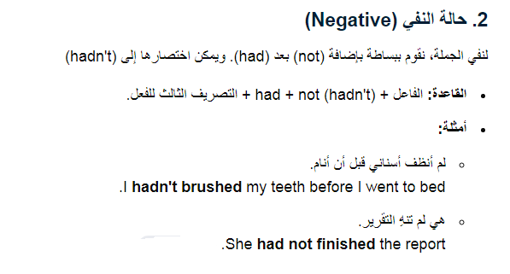

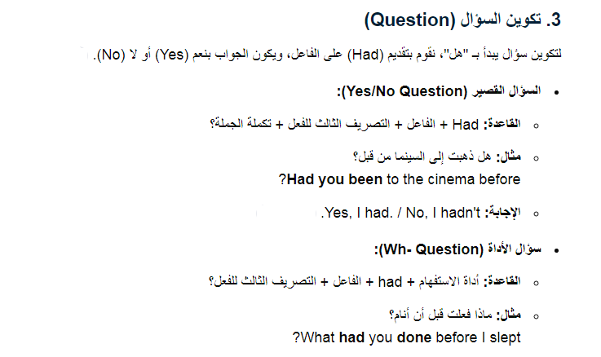

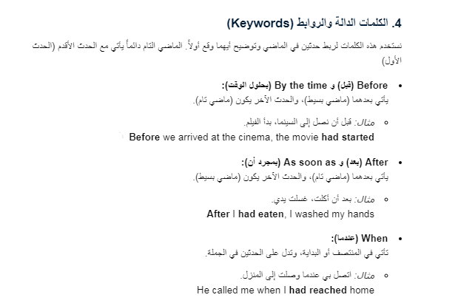

يأتي بعد
1-Before ---------------------- ماضي بسيط+ماضي تام
Before I went o jenin, I had found my wallet.
يمكن عكس الجملة
I had found my wallet before I went to jenin.

2-After--------------- ماضي تام+ماضي بسيط
After they had finished watching the match, they went to bed.
يمكن عكس الجملة لتصبح
They went to bed after they had finished stopped watching the match.
3- ماضي بسيط because+ ماضي تام/ ماضي مستمر
I passed the exam because I had studied hard. (pass,study)
تجاوزت الامتحان لانني درست بجد.
I asked him to stop shouting because I was sleeping.(ask, sleep)
Ali didn’t go with us to Jericho because he had gone there.(not go,go)

Ali didn’t get into the house because he had lost his keys.( get,lost)

4- until: تتبع بماضي تام مباشرة
The students didn’t understand the lesson until the teacher had explained the lesson twice.( not understand, explain)

5-by+ سنة بالماضي/ تتبع بماضي تام مباشرة
By 1948, by 2014
By 2010, she had learned three languages.(learn)
By 2014, iPhones had appeared in most countries.(appear)

6- ماضي بسيط+ that+ ماضي تام
I suddenly realized that I had left my keys at home.
They remembered that they had taken this lesson.

هذه الافعال الماضية يتبعها ماضي تام
Realized, imagined, knew, pretended, found, remembered.
7-previously , earlier مسبقا/ باكرا
قبل هاتين الكلمتين دائما يأتي ماضي تام
They were surprised when Nadia agreed to buy an new car because she had refused to do previously.

8- The day before: يتبعها ماضي تام قبلها او بعدها حسب مكانها في الجملة
The day before, I had visited him(visit)
I needed to study hard this morning because there was some work that I hadn’t finished the day before.
9- اذا وجدت دلائل المضارع التام +شرط ان تكون الجملة في الماضي ( اي يوجد افعال ماضية في الجملة فاننا نستخدم الماضي التام.
Already, just, yet, since, for
He knew the answer because he had just studied hard.
The teacher asked them to show him the homework,but she hadn’t finished it yet
ربط الماضي البسيط + الماضي المستمر+الماضي التام في جملة واحدة
كيف احل الجملة؟؟
اولا: حسب الدلائل الموجودة في الجملة
ثانيا: حسب نوع الفعل بين الاقواس (لحظي او استمراي)

ثالثا: حسب معنى الجملة

When I was walking to work, I suddenly realized that I had left my keys at home.( walk, realize, leave)
Walk فعل استمراري
Realize فعل لحظي
leave تحول الى ماضي تام لان جاء قبله كلمة (that)

مجموعة اسئلة تدريبية على الماضي المستمر وترابط الازمنة معه

A Choose the right answers between brackets.
- I (met – was meeting) your brother while I (studied – was studying) in London.
- While you (played – were playing) the piano, I (was writing – wrote) a letter.
- I (found – was finding) the ring as I (dug – was digging) in the garden.
- When I (arrived – was arriving) at the house, he (was still sleeping – still slept).
- He (sits – sat – was sitting) in a restaurant when I (see– saw – was seeing) him.
- What story (does Sami tell – did Sami tell – was Sami telling) you when I came into the room?
- She (lived – was living) in England when the war (began – was beginning).
- She (was talking – talked) to her neighbor when the baby (began – was beginning) to cry.
- They (went – were going) to the market when they met Ali.
- You (studied – were studying ) when she called.
- While we (were having – had) the picnic, it (started – was starting) to rain.
- While I ( was writing – wrote ) the email, the computer suddenly went off.
- I asked him to come back later because I (was working – am working – worked)
- While I was leaving the house, the phone (was ringing – rang)
- She (had taken – took – was taking) a taxi to the station and arrived in time.
- I had promised to phone him, so I gave him a quick call while I (had – was having ) my breakfast.
- He gave the right answer, but the teacher (hadn’t heard – didn’t hear – was not hearing) him.
- He got wet during his walk because it (rained – was raining ) and he (forgot – had forgotten) to take an umbrella.
- I (passed-was passing- had passed) the exam easily because I (spent- had spent-was spending) long time studying this subject.
- She said that making the cakes (had taken – took – was taking) a long time.
- When the cakes (had been done - were done - did - had done) they (tried – were trying – had tried) one and it (was - had been) delicious.
- Making the cakes (took- had taken – had been taken) a long time, but it (kept - had kept had been kept) Fatima busy.
- I (had seen - saw - was seeing) the man who (drove - was driving - had driven) fast when the accident (had happened -was happening - happened).

Choose the correct answer.
  - After I some biscuits, I had a drink.
a. have had b. had had c. had d. has had
  - The Chrysler building… the year before the Empire State went up.
a. appear b. has appeared c. had appeared d. was appeared
  - Fadi didn't join us to the cinema because he… the movie the day before.
a. see b. sees c. is seeing d. had seen
  - He didn't go out until his teacher… him to do so.
a. has allowed b. allowed c. had allowed d. is allowing
  - I… to the cinema before I saw the accident.
a. have been b. was being c. had been d. was
  - When he arrived at the station, the train…………
a. leave b. is leaving c. had left d. leaves
  - They ………………..…the office until they… their work.
a. don't leave/ finished b. left/ had finished c. didn't leave/ had finished d. left/ finished
  - She didn't buy a car until she …………money .
a. had got b. gets c. has got d. got

  - People that the Eiffel Tower had already shown the way to build high.
a. realized b. have realized c. had realized d. were realized
  - As soon as the teacher the lesson, the students started to ask their questions.
a. finishes b. has finished c. had finished d. finished
  - When Salma went back to school, she found she………the wrong composition the day before.
a. wrote b. had written c. has written d. is writing
  - Irish people because so many had died of starvation.
a. emigrated b. had emigrated c. are emigrating d. have emigrated
  - After I out the light, I went to bed.
a. put b. had put c. have been put d. have put
  - Before she went abroad, she… her degree.
a. has got b. had got c. got d. gets
  - We cheered as soon as the president……………..
a. appeared b. appears c. had appeared d. has appeared
  - We that car before it broke down.
a- had have b- had c- had had d- have had
  - We had mended that car three times before it down.
a- break b- broke c- had broken d- has broken
  - I met my friend Ali while I to school.
a- had walked b- walked c- was walking d-am walking
  - Hanan's car down while she was driving to Nablus.
a-has broken b- breaks c- broke d- had broken
  - The accident happened while the men the steel.
a-were lifting b- are lifting c- lifted d- were lifted
  - When my friends arrived, I my homework.
a-am doing b-did c- was doing d-have done
  - I didn’t answer the question I had read the question paper.
a- until b- after c- when d- as soon as
  - As soon as he at the airport, he telephoned me.
a- arrived b- had arrived c- has arrived d- arrives
  - He find a job until he had graduated.
a- won’t b- doesn’t c- didn’t d- couldn’t
  - She a teacher before she became a guide.
a- has been b- had been c- was being d- is
  - She her lunch until her husband had come.
a- hadn't had b- won't have c- wasn't have d-didn't have
  - After the report , I handed it to the manager.
a-had finished b- had been finished c- has been finished d-finished
  - They said that the driver the accident.
a-caused b-was caused c- had caused d-has caused
  - I took the medicine when I a meal.
a- have b- have had c- had d- had had

Put the verbs in the correct forms.
  - I needed to be at work early this morning because there was some work that I (1)
…………….. (not finish) the day before. Unfortunately, just as I (2) (leave) the
house, the phone …………….. (3) (ring). It was my mother. After talking to her, I (4)
…………….. (run) to the bus stop, but the bus (5 ) (already go)
  - While I ………………in Amman, I an old friend of mine. ( stay, meet)
  - Where …………….you………………….after you……….here yesterday? ( go / leave )
  - The teacher ……….her to show him the homework, but she………it yet. ( ask / not finish )
  - When I …………to the meeting, half an hour late, everyone for me. ( get / wait)
  - He knew something funny………………, but he………what it was. (just happen/ not know)
  - When I ………to work, I suddenly realized that I ………….my keys at home. (walk /leave)
  - The telephone (ring)…………..…….. just as I (leave) the house.
  - He (have)……………….. his dinner while I (have) a bath.
  - As they………………….…….. ( work), a man… ( knock) at the door.
  - What ………….you… (do) when I came in?
  - Mazen…………….. (drink) much tea before he (finish) his supper.
  - After Nadia ……………….….... (cook) the food, her father (come).
  - They…………….… (leave) Rafah before I (reach).
  - Sami……………….. (go) to school after he (take) his breakfast.
  - She …………………….. (thank) him because he… (save) her daughter.
  - When her husband ………………. (arrive) home, Anne (watch) television.
  - I ………………. (prepare) dinner when the telephone (ring)
  - What ………………. (you do) when the postman (arrive)?
  - Julie ………………. (learn) to drive when she………………. (work) in London.
  - Where ………………. (you sit) when the show (begin)?
  - What ………………. (you see) while you (wait) for the bus?
  - Where ………………. (he go) when his car (break) down?
  - Julie ………………. (meet) Peter when she (walk) in the park.
  - When I ……………….into the room, everyone (walk / work)
  - What……………. when I……………….. you last night? (do / call)
  - At 7 pm yesterday, we …………………….. to music. (listen)
  - I …………… to the doctor 2 days ago because I… a terrible headache. (go / have)
  - He ……………… the train because he with some friends. (miss/talk)
  - I …………….what they about.(not understand / talk)
  - Nahla ………….... off the lights and to bed. (turn / go)
  - Some people …………….. (talk) during the film so he (ask) them to be quiet.
  - We …………….. (feel) tired because we (walk) 7 miles .
  - I …………….. (see) Carol at the party. She (wear)a really nice dress.
  - While Sami …………….. (paint) the door, he …………….. (notice) a snake (be) in the
store a long time.
  - They got wet during their walk because it ……………..and they ……………..to take their umbrellas. (rain/forget)
  - The film wasn't very good. I (not enjoy) it very much yesterday.
  - I was waiting in the queue at passport control when suddenly I (realize) that I
… (forget) my passport.
  - As soon as I saw the photo I who it was. (recognise )
  - I took the book back to the library when I reading it.( finish )
  - When I told them about my mistake they all… ( laugh).
  - They didn't really understand until she… it twice. (explain )
  - They ……….……to go for a walk while the sun …………. (decide shine )

  - When I …….……..I knew immediately that something strange ………..( arrive happen)
  - At eight O’clock last night, I (study)
  - After talking to her, I ran run to the bus stop, but the bus. (already go).
  - He………………me to his party, but I ( invite /not go )
  - The day before, I …………. to phone him, so I gave him a quick call while I my
breakfast . ( promised / have )
  - I thought the baby ……………….. because he… hungry. ( cry / be )
  - I… ………..…..(wait) for Ali all day, but he (not arrive)home yet.
  - As soon as I ……… the phone number, I …………… who was calling. (see/ know)
  - Ahmed ………………… his car until he …………… a new one. (not sell/ buy)
  - I …………………you back yesterday because I my mobile. (not call / lose)
  - Mother ………………… shopping this morning because it (not go / rain)
  - As I ………….. to catch the bus, my books on the ground. (run/ fall)
  - He said something, but I …………………. (pretend) that I (not hear).
  - It …………………………(not be) acceptable until you (apologize)………………….

Rewrite the following sentences using the words in brackets.
  - She didn’t get married till she had graduated. (when)
  - After I had studied, I went to bed. (till)
  - She wrote a postcard then she went to the post office. (before)
  - He left the room after taking permission. (before)
  - After watching the film, he went to bed. (until)
  - The teacher asked the question. Then the student answered it.(after)
  - As soon as I heard that. I went out. ( until)
  - I did my homework. Then I watched TV.( after)
  - I had finished my work before the Captain came. ( by the time )
  - He had called the doctor. I got there.(when)
  - He had found the book, and began to read it.( as soon as )
  - I had read the book, I didn't see the film.( until)
  - The patient (die). the doctor (arrive). (by the time)
  - Ahmed's car (break) down. He (drive) to Gaza.( while )
  - I (drive) to work. I (crash) my car.( when)
  - I (walk) in the street. I suddenly (fall) over. (while)
  - I (walk) in the street. It (rain) heavily. (while)
  - The accident happened, then the ambulance arrived at the place. (as soon as(
  - The students (shout). The teacher (get) very angry. (because)
  - I (take) the book to the library. I (finish) reading it. (when)

Correct the mistakes in the sentences.
  - When has your brother arrived home last night?
  - The policeman caught the thief who stole the money.
  - When the phone rang, I were working in the garden.
  - After I finish my homework, I went to the seaside.
  - I found the book which I have lost last week.
  - He did not wrote his report till he had read the book.
  - She washed her face and comb her hair.
  - What subjects have you studied last year?
  - Have you seen the film last night ?
  - After talking to my mother, I ran to the bus stop, but the bus has already gone.
  - They understood until she had explained it twice.
  - While he looks around the room, he heard someone come in.

ثانيا الفرع الأدبي

